WSA TRAINING PROJECT DOCUMENTAION FRAMEWORK

REQUIREMENTS & DESIGN

**DOCUMENT**

Web Stack Academy (P) Ltd



**Whack a Penguin**

**1. Introduction**

Whack a penguine is a game, which will be played by a single user. Whenever user click on image it should pop – up a penguine. If the penguine image is yeti, then user should get a message “ROARRRRRR” along with the yeti image.

# **2. Requirement details**

Initially 9 default images will be displayed to the user. When user points mouse on the image that image should be changed to another image. When user clicks on the image, randomly generated he game runs until user finds a yeti. Images are displayed randomly to the user. When user finds a yeti game should be stopped with a message of roar and a button to start a new game.

**2.1 User Interface:**

* Initially there will be a 9 image with clickable property as shown below



**Find the Penguine**

* Whenever user points mouse on the image it should display the image with question mark as shown below:



* When user clicks on the image it should display the penguine image like below:

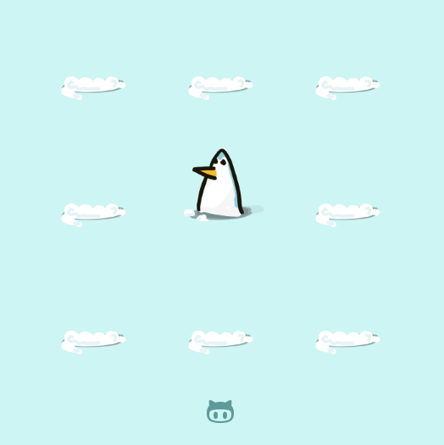

* If user clicks on Yeti image then output should be,

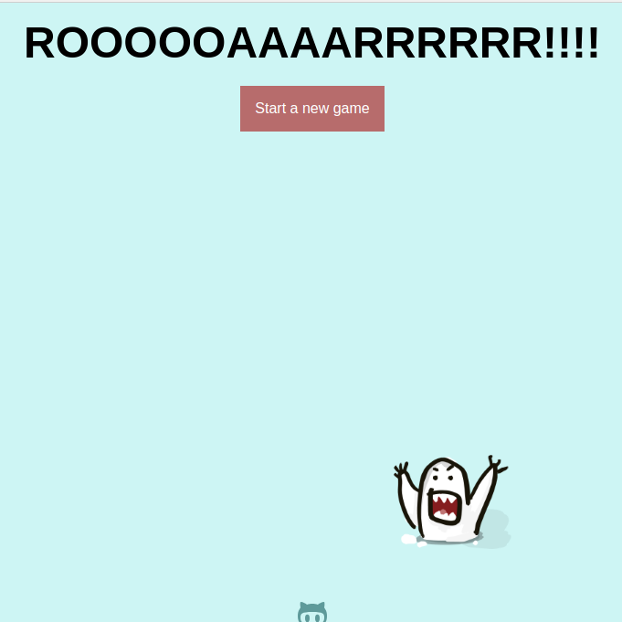

# 3. Coding guidelines

* Use proper naming conventions , variables, functions, data types.
* Do not hard code values.
* Add block comments for functions and wherever applicable.

# **4. References**

* Required images are avalable in the google drive, students can refer those images

link to images : https://drive.google.com/drive/u/1/folders/1ru_-x60ribFGEdzcIJu9DhfUbYAwM78K